AnywherePrints Webprint Instructions
When printing from workstation, laptop, tablet, or smartphone
Visit: webprint.niu.edu
- Enter_Username and Password

- Select_Web Print from the left panel
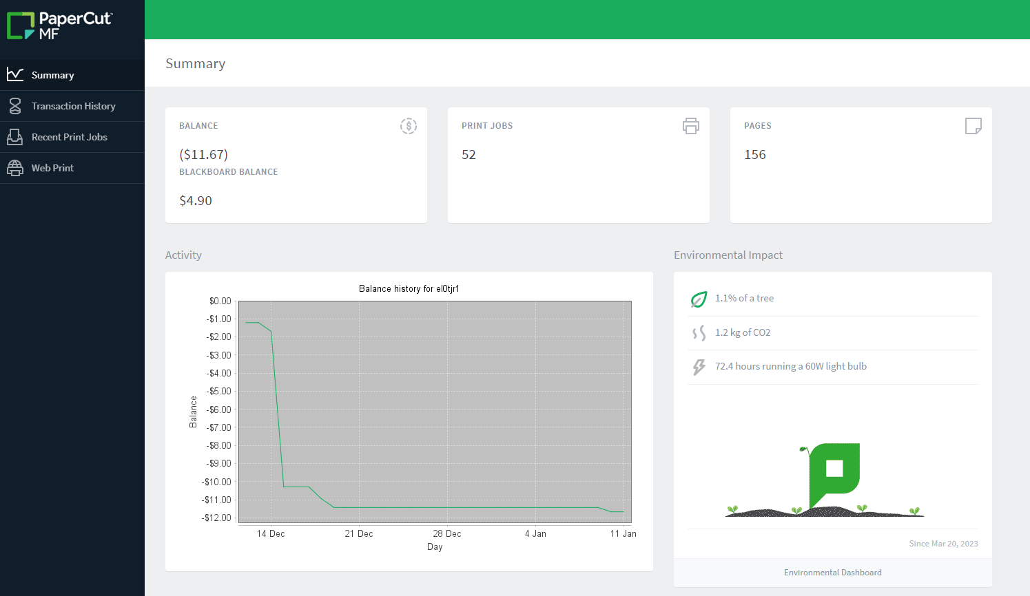

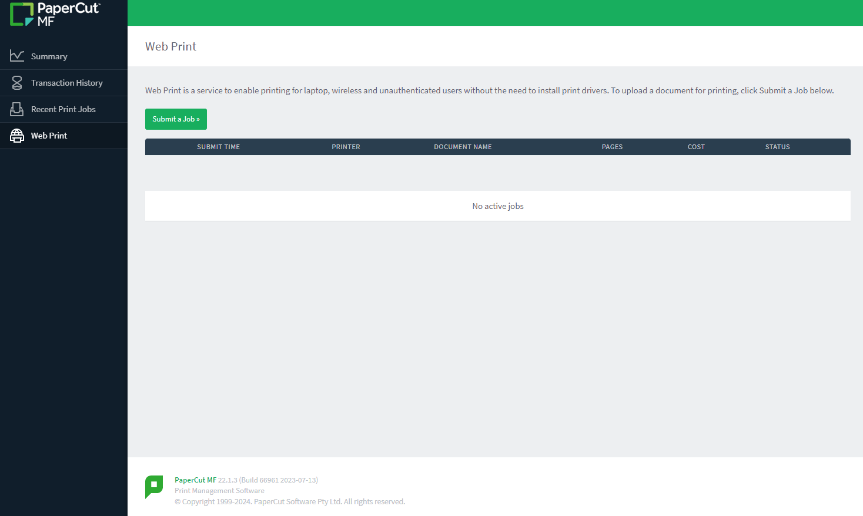
- Select_Submit a Job

- Select either: pcprint1\Papercut-Black/Grayscale for black printing only, or
pcprint2\PaperCut-Color for color printing
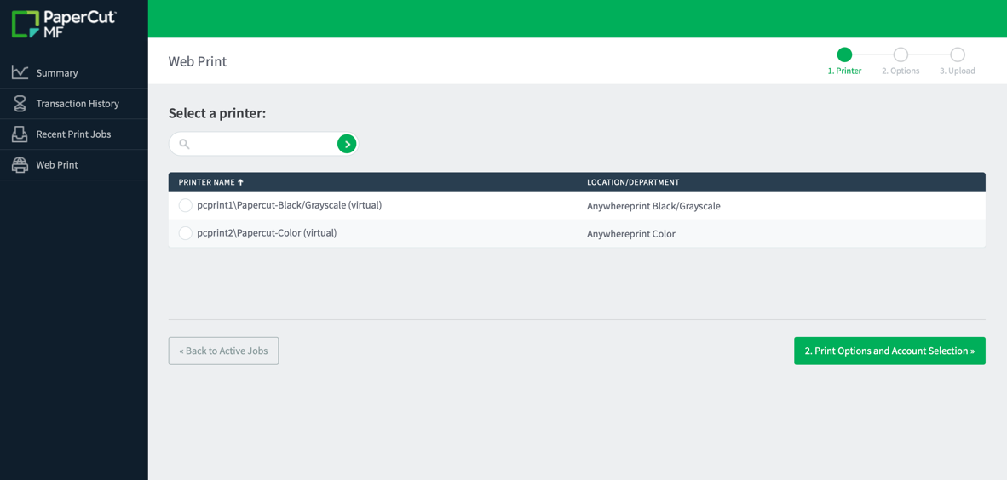
- Select 2. Print Options and Account Selection

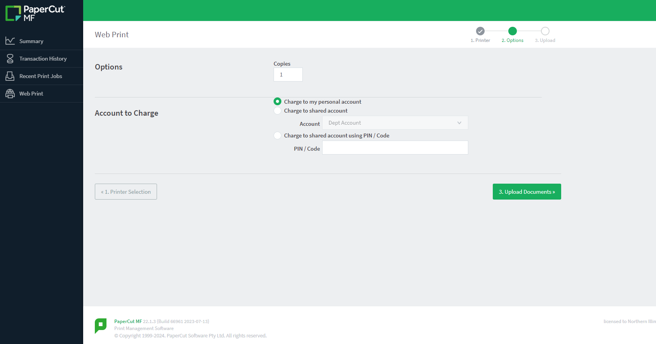
- Select_Charge to my personal account or Charge to shared account
- Select_3. Upload Documents
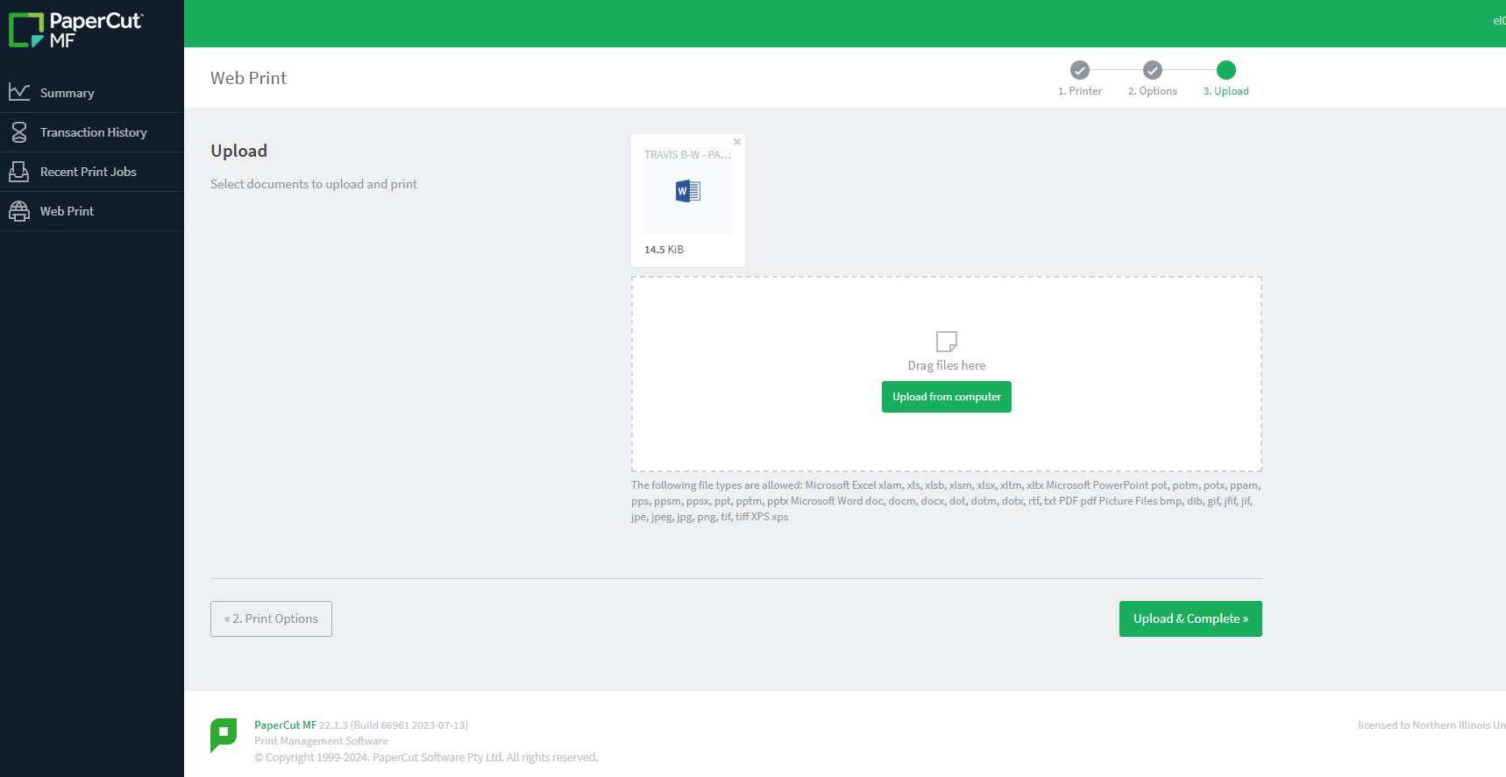
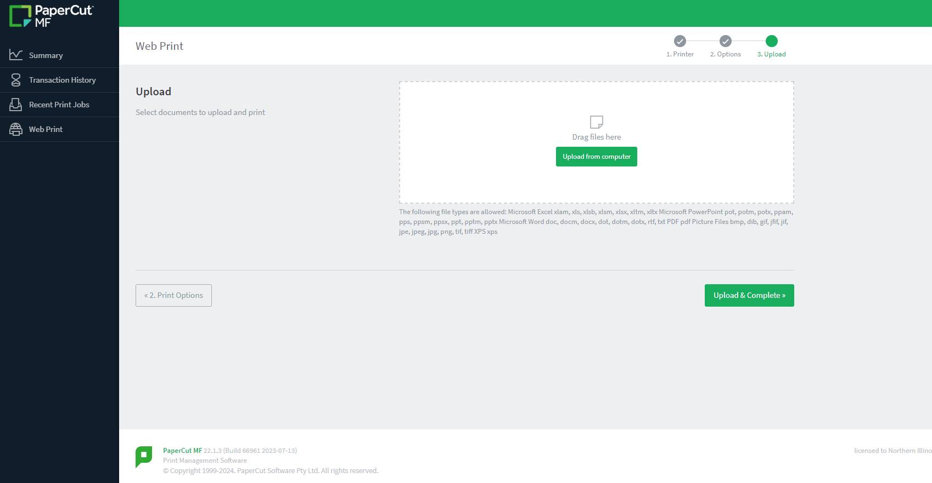
- Select_Upload from computer by dragging your file as indicated.
- Your document icon will be displayed. You may now Select Upload & Complete

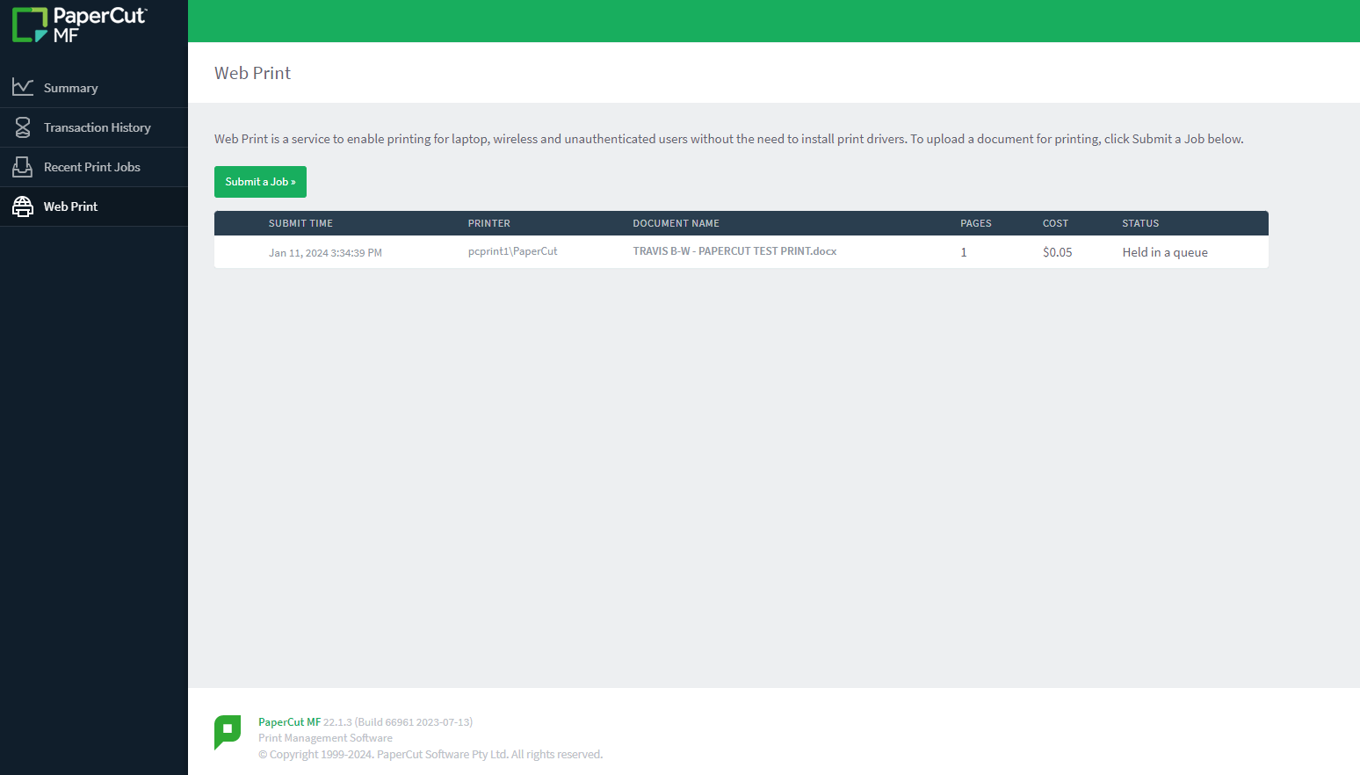
You should now see your print job with a Status of Held in a queue

You will receive a screen notification of pending document ready for release at an AWP printer. Proceed to any Ricoh device to release your job.
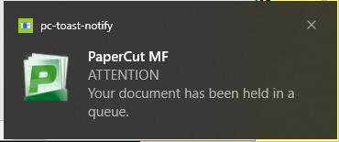

At the Ricoh print device, you will be able to change a color doc to print as grayscale and/or change
to 2-sided printing before you select to “Print” your document(s). You can do this as a single document or all documents pending print.

