**Changing Tray Paper Size – Ricoh IM C300**These instructions will guide you through the process of changing the tray size on the printer when placing different size paper in the tray(s).

1. 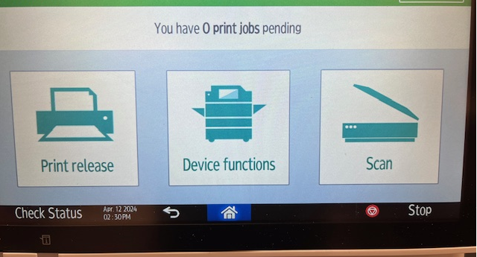To change size, select Device functions

1. 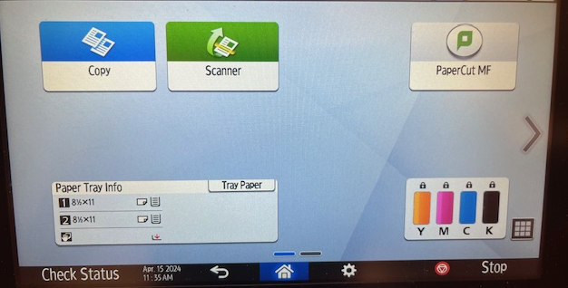Select Tray Paper
2. 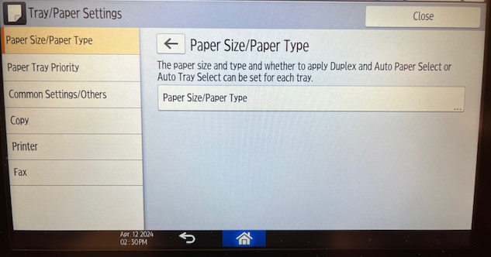Select Paper Size/Paper Type
3. 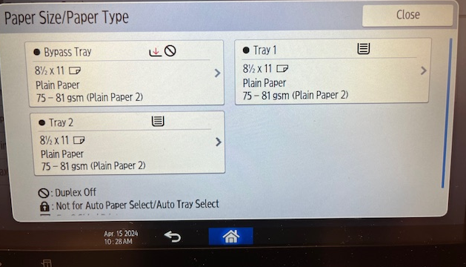Select the Tray the new size paper was added
4. 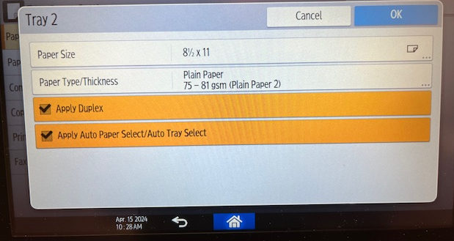Select Paper Size
5. 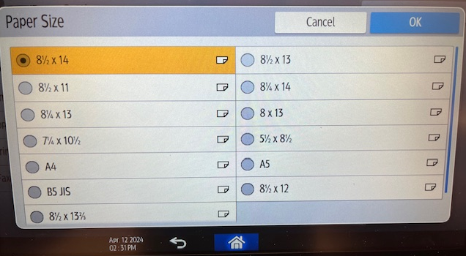Select new Paper Size, then select OK
6. 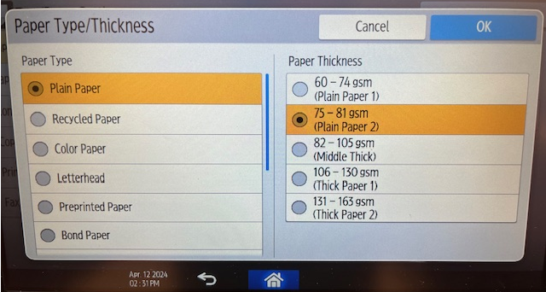Select Paper Type/Thickness, then select OK
7. 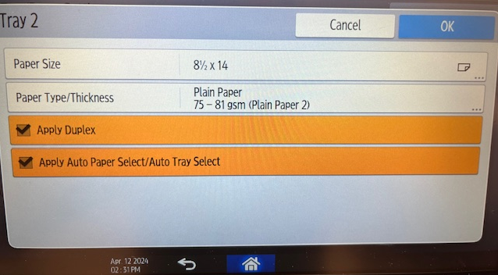Select OK if the changes are correct. If incorrect, back arrow to step 6.
8. 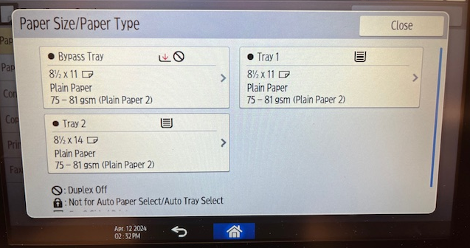Verify the Paper Tray size is correct and select the Home icon at the bottom