**Device functions scanning – Scanning a document to an alternate email**These instructions will guide you through the process of scanning a document to an email using the Ricoh Device functions scanning. This option provides you an extensive tool set for greater document enhancement and is the best solution when scanning large files.

1. 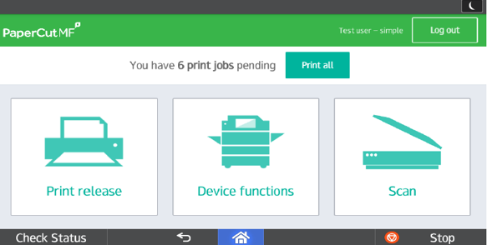Select Device functions then select Departmental or Personal account (there is no charge for scanning)

1. 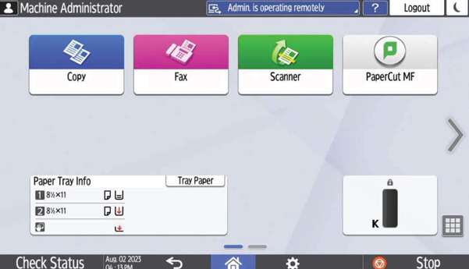Select Scanner
2. 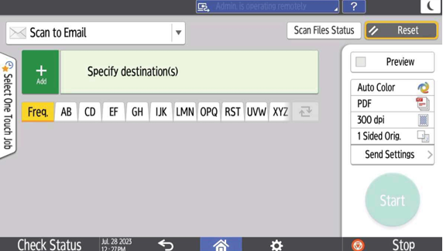Enter email address or select one from the list and place document(s) in the feeder or on the glass  
   4. Select Start **or** choose Send Settings if you would like changes to settings before scanning  
     
   Selecting the Send Settings button will give access to additional settings that can be made.

Some frequently used ones are:

* **File Type** – High Comp. PDF (use if scanning a large number of documents), TIFF, JPEG. Etc..
* **Original Settings** – allows the selection for a 2-sided original
* **File Name** – name the image being created (usually PDF)
* **Subject** – allows the sender to name the subject rather than using the generic name
* **Delete Blank Page** – will remove blank images

