**PaperCut scan – Scanning a document to your email**These instructions will guide you through the process of scanning a document using your personal OneCard to send a scanned document to your email using the PaperCut Scan tool.

1. 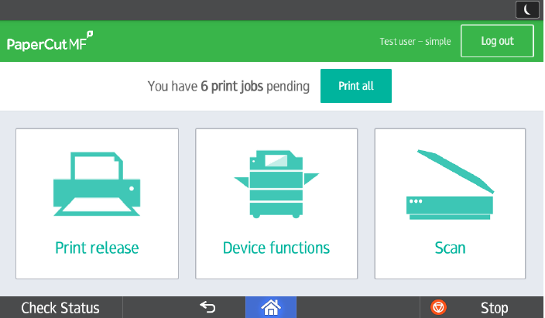Select Scan then select Departmental or Personal account (there is no charge for scanning)
2. Place your document(s) in the feeder or on the glass  
   3. Optional step only   
    a. The Subject line can be changed (see screen capture below)

b. Change Settings options (see screen capture below)

c. Check “Prompt for more pages” if you adding extra pages to the file from the feeder or glass

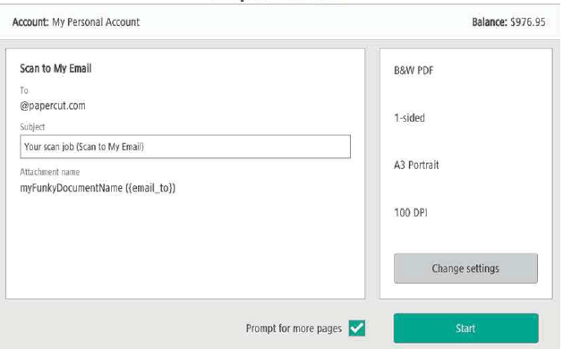4. Select Start *(follow on screen instructions when scanning multiple pages)*

